Media release
10th June
Supply and demand drive up values
The latest monthly property value index shows that nationwide residential values increased further in May. The annual change in values remains 7.1%, with an increase of 1.7% over the past three months. Values are now up 5.0% over the previous market peak of late 2007.

Jonno Ingerson, QV.co.nz Research Director said “Nationwide values continue to climb strongly, but that isn’t the case right across the country. Values are increasing fastest in Auckland and to a lesser extent Christchurch, with both cities driven by a lack of supply”.

“The rest of the main centres are also increasing in value, although at a much more modest rate, reflecting a general increase in consumer confidence. Values are more variable in the rural towns in response to local economic conditions,” said Ingerson.

“Given that the current increase in values in Auckland and Christchurch is largely driven by strong demand and short supply, values are likely to continue to increase in the coming months,” said Ingerson.

Auckland
Values across Auckland have again increased, now up 12.7% over the past year. Over the past few months values in Rodney and old Auckland City had been increasing slower than the rest of Auckland. However both have seen an increase over the past three months, 3.3% and 3.7% respectively, which now aligns with growth in the rest of the city. Waitakere has again seen the highest increase at 3.9% over the past three months. Overall, values are still rising and well above last year, with North Shore, old Auckland City, Waitakere and Manukau all around 12-13% up on last year.

QV Operations Manager Kerry Stewart said “Prices are still very high across Auckland as a somewhat desperate feel amongst buyers who are searching for good properties at reasonable prices is appearing. The speed with which people have to make an offer has seen some forego the usual due diligence, which leaves them exposed to potential risks associated with the property.”

“Buyers are still looking further afield with areas such as Mt Roskill in the central southern suburbs seeing sales up to and over $1 million. Prices this high have previously been very uncommon,” said Stewart.

Hamilton and Tauranga
Outside of Auckland, the main cities are generally still increasing. Although improved confidence in areas such as Tauranga continues, values are still fluctuating and show little sign of increasing as much as other main cities. The small amount of growth seen in Tauranga last month has faded, now only 0.5% up over the past three months. This leaves Tauranga 0.2% down on this time last year.

QV Valuer Paul Thomas said “Although there is increased confidence this hasn’t translated to an increase in values. There is continued buyer enquiry from Aucklanders however few are actually turning into purchasers due to lack of employment opportunities.”

Hamilton has also slipped back slightly with 0.9% growth over the past three months and a 4.3% increase on last year.

QV Valuer Richard Allen said “There appears to be a steady supply and demand in the market as well as early signs of investors starting to take more interest in the market.”

Wellington
Values in the Wellington area are showing some growth, albeit steady. Values are now 2.7% above this time last year with a 0.8% growth in the last 3 months. Within Wellington, Wellington City, Hutt City and Upper Hutt all have around a 2% increase on last year, however, Porirua has seen the biggest increase, now up 4.2%.

QV Valuer Pieter Geill said “There is increased demand from buyers in the Hutt Valley for properties up to $400,000, as well as buyers looking around the $400,000-$600,000 mark. Property investors are also still active, with many purchasing low value homes before making a modest profit after making only small to medium sized renovations. They are also interested in blocks of flats.”

Christchurch and Dunedin
Christchurch values have increased this month, now 10% above last year. The outlying areas such as Waimakariri and Selwyn have also continued to grow despite slowing growth rates in the past few months. Both Waimakariri and Selwyn have seen 2.9% increases over the past three months.

QV Valuer Daryl Taggart said “The market continues to go from strength to strength. We have seen some good interest in the middle to upper end of the market where buyers looking to upgrade to their second or third homes are spending $500,000 plus. There is also a noticeable increase in popularity with modern homes in subdivisions built within the last 10 years or so.”

Dunedin has slowed slightly, with only a 0.2% increase over the past three months. Values still sit 4.2% above last year.

QV Valuer Tim Gibson said “Unlike last month, we are starting to see the affect of the normal winter slowdown starting to take place. Whereas the beginning of the month was a good one, especially for the lower end of the market, the latter half has seen a noticeable drop off in demand.”

Provincial centres
The provincial centres generally remain steady. It is mainly areas in the middle of the North Island, such as Taupo, that saw decreases in values over the past three months. Areas such as Hawke’s Bay and Wairarapa are seeing most activity in the lower end of the market with buyers cautious and sellers realistic on regard to price expectations. Whangerei and Gisborne, which have previously been declining, have continued to grow in recent months.

For media enquiries and interviews, and for further information contact:
Jonno Ingerson
Research Director QV.co.nz
Tel: 04 802 1239
Mobile: 027 454 6642
Email: jonno.ingerson@propertyiq.co.nz

For further specific comment on local areas:
Auckland. Kerry Stewart 021 387 106
Hamilton. Richard Allen 027 230 7290
Tauranga. Paul Thomas 027 544 4602
Wellington. Pieter Geill 027 230 7291
Christchurch. Daryl Taggart 027 304 9815
Dunedin. Tim Gibson 021 151 2887

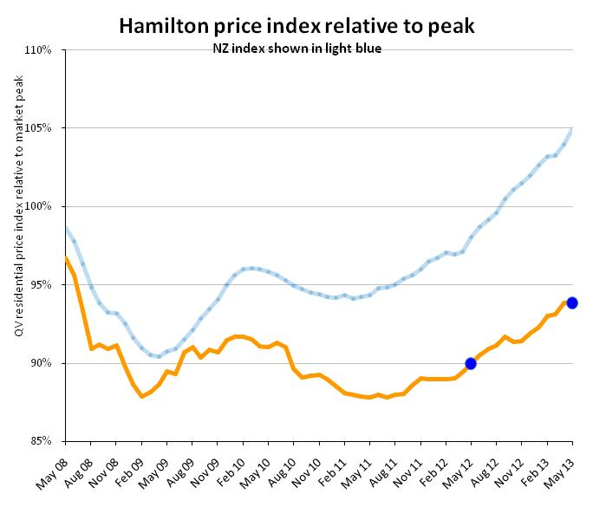
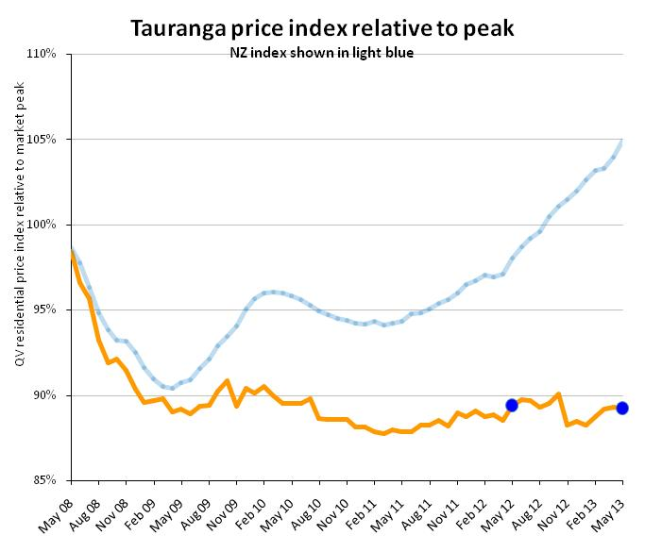
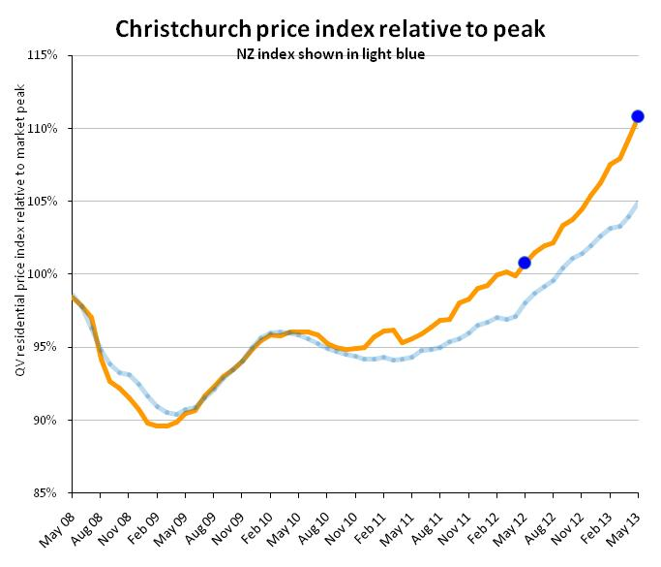
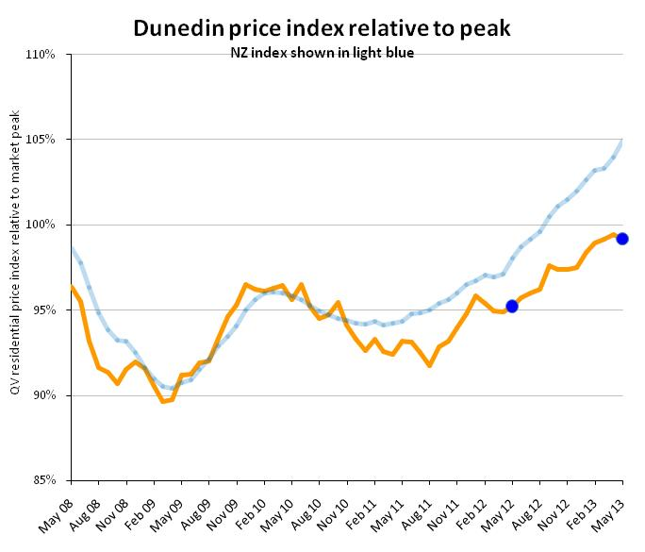
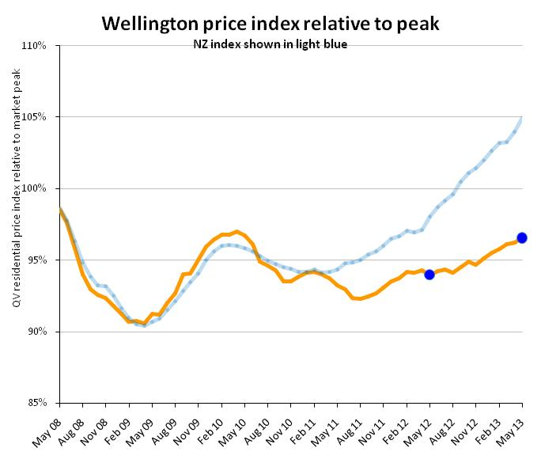
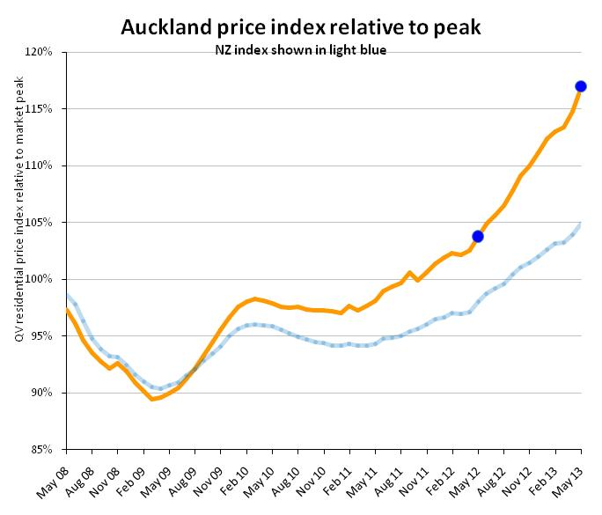

PropertyIQ Value Index - Residential Property
Time period: as at May 2013
 | Territorial authority | Average current value | 12 month change% | 3 month change % | Since 2007 market peak change %
 | Far North | 312,993 | 0.3% | 0.3% | -23.2%
 | Whangarei | 329,285 | 0.0% | 1.6% | -16.8%
 | Kaipara | 315,212 | 3.7% | 1.7% | -21.4%
 | Auckland - Rodney | 606,122 | 8.6% | 3.3% | 2.4%
 | Rodney - Hibiscus Coast | 605,938 | 8.9% | 3.6% | 3.2%
 | Rodney - North | 605,087 | 8.3% | 2.6% | 0.7%
#A | Auckland - North Shore | 743,810 | 12.9% | 3.6% | 16.0%
 | North Shore - Coastal | 861,232 | 13.3% | 4.6% | 14.3%
 | North Shore - Onewa | 585,659 | 13.4% | 2.1% | 18.1%
 | North Shore - North Harbour | 715,951 | 11.5% | 3.5% | 17.8%
#A | Auckland - Waitakere | 482,338 | 13.5% | 3.9% | 13.3%
#A | Auckland - City | 751,429 | 13.1% | 3.7% | 20.4%
 | Auckland City - Central | 684,799 | 13.3% | 4.6% | 20.2%
 | Auckland City - East | 920,652 | 11.1% | 2.1% | 15.5%
 | Auckland City - South | 670,592 | 15.6% | 4.8% | 24.6%
 | Auckland City - Islands | 683,068 | 6.4% | 3.5% | 6.9%
#A | Auckland - Manukau | 518,525 | 12.1% | 3.3% | 12.8%
 | Manukau - East | 694,449 | 12.7% | 3.5% | 16.5%
 | Manukau - Central | 395,722 | 11.5% | 2.7% | 5.3%
 | Manukau - North West | 420,484 | 12.3% | 3.5% | 13.8%
#A | Auckland - Papakura | 378,513 | 8.8% | 2.7% | 5.3%
 | Auckland - Franklin | 415,855 | 7.7% | 3.7% | 2.5%
 | Thames Coromandel | 489,813 | 0.7% | -0.8% | -16.4%
 | Hauraki | 245,549 | 2.5% | 2.9% | -14.0%
 | Waikato | 274,727 | 6.9% | 3.4% | -15.2%
 | Matamata Piako | 260,405 | -1.2% | -1.4% | -13.0%
# | Hamilton | 347,351 | 4.3% | 0.9% | -6.2%
 | Hamilton - North East | 431,705 | 4.2% | 1.4% | -4.0%
 | Hamilton - Central & North West | 326,761 | 3.9% | 0.9% | -8.7%
 | Hamilton - South East | 323,367 | 4.4% | 1.0% | -7.5%
 | Hamilton - South West | 309,419 | 3.8% | -0.5% | -9.6%
 | Waipa | 323,254 | 4.7% | 1.3% | -4.4%
 | Otorohanga | N/A | N/A | N/A | N/A
 | South Waikato | 130,750 | -0.3% | 0.0% | -19.9%
 | Waitomo | 143,957 | 0.0% | -2.6% | -35.0%
 | Taupo | 348,201 | -0.4% | -0.9% | -14.1%
 | Western BOP | 385,975 | -1.5% | -4.9% | -15.2%
# | Tauranga | 428,583 | -0.2% | 0.5% | -10.8%
 | Rotorua | 269,558 | 0.6% | 0.1% | -13.2%
 | Whakatane | 293,590 | -1.1% | 0.8% | -15.4%
 | Kawerau | N/A | N/A | N/A | N/A
 | Opotiki | 209,660 | -0.2% | -0.1% | -25.4%
 | Gisborne | 228,571 | 0.4% | 1.4% | -24.4%
 | Wairoa | N/A | N/A | N/A | N/A
 | Hastings | 300,032 | 3.3% | 1.7% | -4.5%
# | Napier | 322,685 | 3.1% | 0.7% | -5.5%
 | Central Hawkes Bay | 205,740 | -6.1% | -5.1% | -23.2%
 | New Plymouth | 334,101 | 4.6% | 1.9% | -0.1%
 | Stratford | 198,710 | 4.8% | 2.4% | -8.6%
 | South Taranaki | 179,448 | -3.3% | 0.0% | -9.6%
 | Ruapehu | 133,800 | -10.7% | -5.7% | -26.3%
 | Wanganui | 191,430 | 0.1% | -0.2% | -12.7%
 | Rangitikei | 148,551 | 1.8% | -1.1% | -17.3%
 | Manawatu | 234,717 | 0.5% | -1.3% | -7.6%
# | Palmerston North | 284,808 | 2.3% | 0.4% | -5.2%
 | Tararua | 153,073 | -1.0% | -1.5% | -12.2%
 | Horowhenua | 199,738 | 0.2% | 0.8% | -16.5%
 | Kapiti Coast | 362,232 | 0.8% | -0.2% | -5.6%
#W | Porirua | 377,608 | 4.2% | 2.5% | -1.4%
#W | Upper Hutt | 332,547 | 2.0% | 1.0% | -6.4%
#W | Hutt | 367,342 | 2.2% | 1.2% | -7.5%
#W | Wellington | 524,558 | 2.8% | 0.4% | -2.4%
 | Wellington - Central & South | 531,146 | 1.5% | 0.5% | -5.2%
 | Wellington - East | 571,046 | 3.6% | -0.5% | -0.9%
 | Wellington - North | 458,071 | 2.6% | 0.5% | -1.7%
 | Wellington - West | 604,724 | 4.9% | 1.1% | -0.4%
 | Masterton | 239,437 | -0.1% | 3.9% | -17.3%
 | Carterton | 250,985 | 3.6% | -2.4% | -9.1%
 | South Wairarapa | 289,688 | -0.7% | 0.4% | -15.4%
 | Tasman | 404,285 | 4.2% | 1.9% | 1.5%
# | Nelson | 393,171 | 3.9% | 0.8% | 2.9%
 | Marlborough | 341,912 | 2.1% | 0.8% | -12.4%
 | Kaikoura | N/A | N/A | N/A | N/A
 | Buller | 223,398 | 1.9% | -0.7% | 7.6%
 | Grey | 218,287 | -0.1% | 2.4% | -9.5%
 | Westland | 224,733 | 0.2% | 2.0% | -9.4%
 | Hurunui | 316,571 | 4.5% | -3.9% | 0.0%
 | Waimakariri | 378,446 | 6.8% | 2.9% | 18.7%
# | Christchurch | 424,721 | 10.0% | 3.0% | 10.8%
 | Christchurch - East | 324,713 | 8.3% | 1.5% | 4.9%
 | Christchurch - Hills | 597,257 | 7.8% | 2.2% | 8.0%
 | Christchurch - Central & North | 491,706 | 11.5% | 3.5% | 11.1%
 | Christchurch - Southwest | 392,417 | 10.6% | 3.6% | 15.6%
 | Christchurch - Banks Peninsula | 502,194 | 16.0% | 6.3% | 4.5%
 | Selwyn | 460,537 | 12.7% | 2.9% | 22.1%
 | Ashburton | 298,636 | 9.9% | 1.2% | 6.6%
 | Timaru | 265,925 | 4.8% | 1.9% | 5.2%
 | MacKenzie | 279,484 | 8.3% | 0.4% | -5.5%
 | Waimate | 188,233 | 7.1% | 5.4% | -1.8%
 | Waitaki | 220,479 | 4.9% | 4.0% | -3.5%
 | Central Otago | 298,162 | 1.8% | 1.8% | -6.1%
 | Queenstown Lakes | 633,197 | 4.5% | 1.9% | -11.4%
# | Dunedin | 284,346 | 4.2% | 0.2% | -0.8%
 | Dunedin - Central & North | 292,031 | 3.7% | -0.2% | -3.2%
 | Dunedin - Peninsular & Coastal | 257,928 | 0.5% | 0.5% | -4.7%
 | Dunedin - South | 277,305 | 6.7% | 1.1% | -2.9%
 | Dunedin - Taieri | 293,913 | 4.3% | 0.4% | 0.0%
 | Clutha | 163,758 | 1.1% | -0.4% | -9.7%
 | Southland | 208,487 | -2.2% | 1.5% | -10.4%
 | Gore | 183,355 | 0.7% | -0.2% | 3.7%
# | Invercargill | 208,188 | 2.0% | 1.0% | -7.2%
 | Auckland Area | 640,106 | 12.7% | 3.5% | 17.0%
 | Wellington Area | 444,085 | 2.7% | 0.8% | -3.5%
# | Main Urban Areas | 501,364 | 9.0% | 2.3% | 9.3%
 | Total NZ | 436,097 | 7.1% | 1.7% | 5.0%
Notes on the above data:
1. The information included in the above table is based on the monthly property value index. This index is calculated based on the sales data entered into PropertyIQ's system in the previous 3 month period. For example, information for the period ending June will be calculated based on sales entered between April 1 and June 30.
2. The average current value is the average (mean) value of all developed residential properties in the area based on the latest index. It is not an average or median sales price, as both of those only measure what happens to have sold in the period.
3. The percentage change over three months, twelve months and since the 2007 market peak are based on the change in the property value index between that time and the current.
4. Any of the statistical data shown in italics are calculated based on a sample set of data that is less than the recommended minimum. These results should be used with caution. Those showing N/A had too few sales to generate an index

